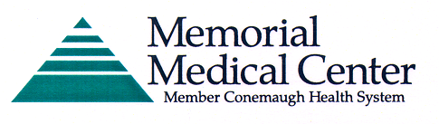

Conemaugh School of Nursing & Allied Health Programs
Transcript Request

To request a transcript, please complete the information below. All official transcripts are mailed using first class mail because the School’s Seal cannot be affixed to a fax or electronic copy. (Please allow time for standard mail delivery). Unofficial transcripts may be faxed or emailed. During the academic year the transcript requests are processed within five business days of receipt of your request. There is no fee to process Official and Unofficial Transcripts.

Number of  Transcripts Requested | Official Transcript Requested | Unofficial Transcript Requested

Select Program of Study:
School of Nursing | School of EMS | School of Histotechnology
School of  Medical Laboratory Science | School of  Radiologic Technology | School of  Surgical Technology

Current Name: _________________________________________________________________

Name under which you attended the program: ________________________________________

Year of graduation/attendance: ____________________________________________________

Phone: _______________________________________________________________________

Email: _______________________________________________________________________

Complete name and address of where the transcript is to be mailed:

Return this form to:

Conemaugh School of Nursing & Allied Health Programs

Attn: Transcript Request

1086 Franklin Street

Johnstown, PA 15905-4398

